# Constructing Definitions: Antiracist (adj)

After reneging on authorized job hiring for Black people in Rochester, busloads of FIGHT protesters went to Kodak's annual meeting in April 1967 in Flemington, New Jersey — with such signs as "Kodak Snaps the Shutter on Negroes." This forced Kodak and other local businesses to make significant changes in their hiring practices. They created a program that trained and employed more than 700 Black community members.

**✎ Add your thoughts on this example as it relates to antiracism.**

|  |
| --- |
| This is considered antiracist because it opposes discrimination and advocates for changes in the economy. |

Example 2

Hannah Storrs, a civil rights leader and Rochester City School District (RCSD) Teacher, was the president of Rochester’s CORE (Congress of Racial Equality) chapter where she organized people of color to fight against poor housing, job discrimination, and segregation. In 1963 she organized a massive protest outside the local operating engineers 832 AFL-CIO Union because they wouldn’t allow Black people in the union. Her protest was part of a coordinated protest movement across several Northern states against job discrimination in trade unions. She also fought for the inclusion of Black history in RCSD curriculum.

**✎ Add your thoughts on this example as it relates to antiracism.**

|  |
| --- |
| This is antiracist because she fought for civil rights for African-americans to improve their social and economic rights. |

Rufus Fairwell managed a gas station in the redlined Plymouth Exchange neighborhood. One night in 1962 Fairwell was locking up his gas station when a group of white police officers arrested him for ‘attempted robbery.’ Once in custody, he was beaten to the point of needing a wheelchair for mobility. Hundreds of protestors, led by Memorial AME Pastor Rev. Gibson, and joined by Rufus Farewell, protested on the steps of Rochester City Hall.

**Photo Caption:** Prayer of Protest: Rev A.N. Gibson offers prayers from City Hall steps to a crowd that marched from Memorial AME Zion Church to protest on behalf of Rufus Fairwell, accused of assaulting two policemen. Gibson is standing with an arm raised in prayer above the crowd.

**✎ Add your thoughts on this example as it relates to antiracism.**

|  |
| --- |
| This is antiracist because the protesters want change against discrimination against African-americans. |

Constructing the Definition

OF THE WORD **ANTIRACIST (adj)**

**✎ Using the three examples above, in your own words, write a definition of antiracist (adj).**

|  |
| --- |
| Actively opposing racism and fighting for changes in economic, political, and social life. |

Identifying Antiracist Civic Actions

|  |  |  |  |
| --- | --- | --- | --- |
| **Example** | | **Identify 2+ examples of civic action from the readings above.** | **Identify the form of civic action for each using the chart on the next page.** |
| **1** |  | 1. Fought for job rights for African-Americans | Civic engagement |
| 1. Protested against Kodak | Civic engagement |
| + |  |
| **2** |  | 1. Organized a protest outside the union | Civic disobedience |
| 1. Organizes protests to improve life for African-Americans | Civic engagement |
| + |  |
| **3** |  | 1. Protested outside the Rochester City Hall | Civic disobedience |
| 2. |  |
| + |  |

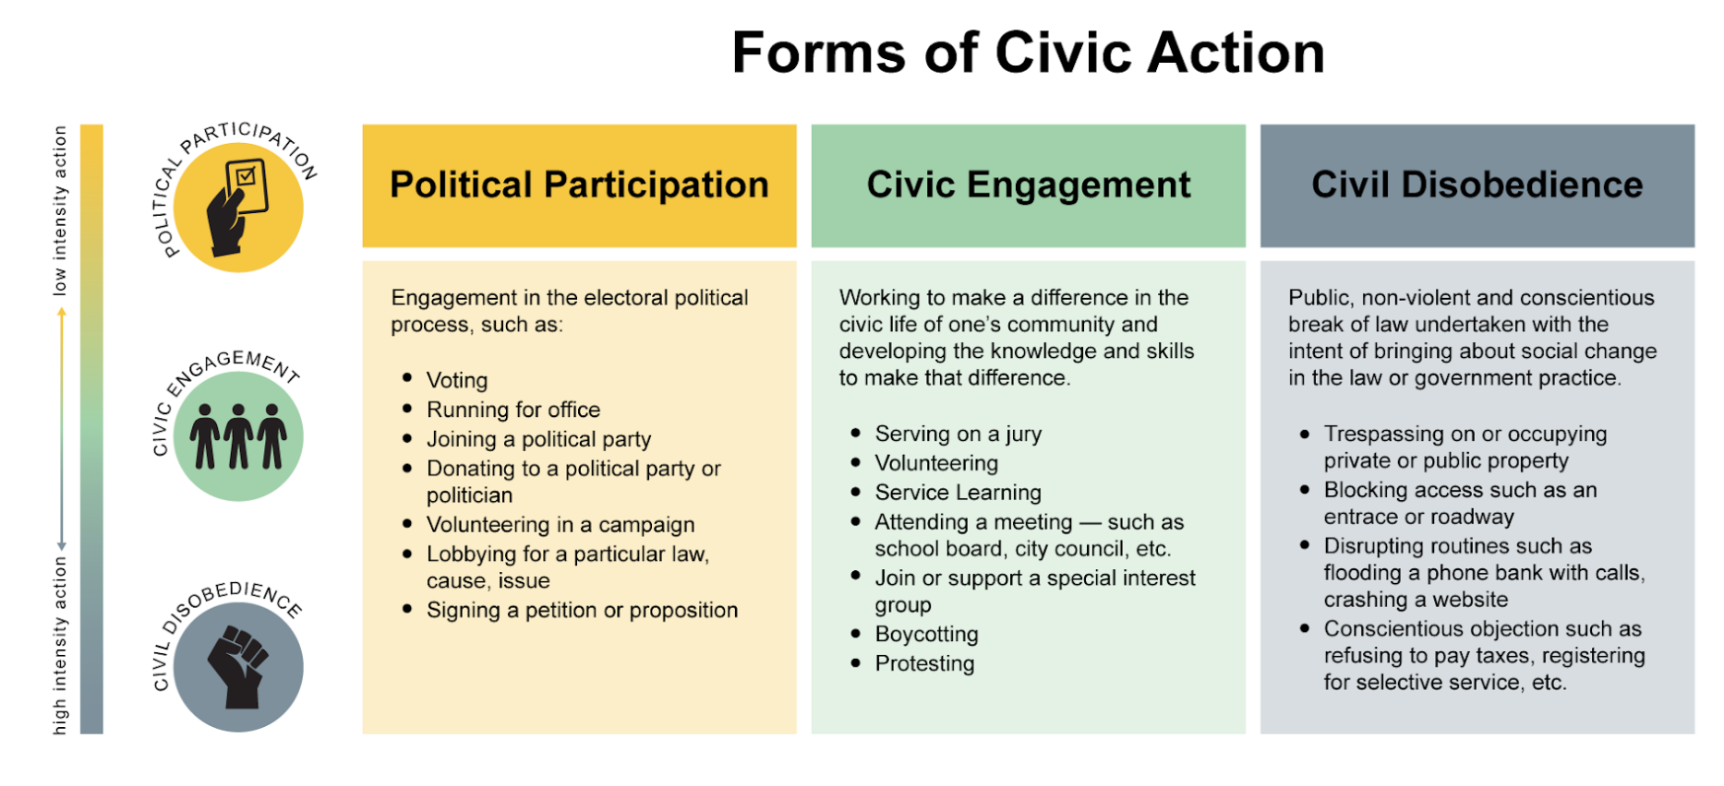

Example 1

Norman Huyck was a wealthy real estate developer in Rochester. He was also the president of the Rochester Builders Association. He helped build thousands of homes in Rochester’s suburbs. When purchasing a house, a document called a deed proves that you own the house. The deed also has rules for how anyone can use your house. Huyck created a rule on all homes he built that stated Black people were not allowed to live in the homes he built.

**✎ Add your thoughts on this example as it relates to racism.**

|  |
| --- |
| Not allowing African-americans to live in the houses he built is discrimation. |

Until 1968, many schools, churches, clubs, and businesses across Monroe County held annual Black face minstrel shows. White students would paint on ‘Black face’ and sing songs mocking the intelligence of Black people. The Democrat and Chronicle wrote hundreds of articles supporting and affirming these shows.

**✎ Add your thoughts on this example as it relates to racism.**

|  |
| --- |
| The black face minstrel shows discriminated African-americans. |

Mary Nicolosi and Dr. Louis Cerulli worked together to prevent Rochester schools from integrating white and Black students in the late 1960s and early 1970s. Nicolosi spoke at school board meetings, organized white parents, and sometimes resorted to violence against students of color and school board members who supported integration.

Former RCSD school board president Dr. Cerulli, fought against school integration. In 1971 he led a rally against integration with close to 4,000 people. He urged parents and students to be ‘militant’ in preventing school integration.

**✎ Add your thoughts on this example as it relates to racism.**

|  |
| --- |
| Wants to prevent African-americans to attend schools with Caucasians. |

Constructing the Definition

OF THE WORD **RACIST (adj)**

**✎ Using the three examples above, in your own words, write a definition of racist (adj).**

|  |
| --- |
| Prejudice and discrimination against a group of people. |

Identifying Racist Civic Actions

|  |  |  |  |
| --- | --- | --- | --- |
| **Example** | | **Identify 2+ examples of civic action from the readings above.** | **Identify the form of civic action for each using the chart on the next page.** |
| **1** |  | 1. Wrote a rule stating African americans cannot live in his house | Political participation |
| 1. President of the Rochester Builders Association | Political participation |
| + |  |
| **2** |  | 1. Democratic Chronicle supported minstrel shows | Civic engagement |
| 1. Black face minstrel shows | Civic engagement |
| + |  |
| **3** |  | 1.Voting against integration for blacks and whites in schools | Political participation |
| 2.organized white parents | Civic engagement |
| + |  |

